1. **GROUP BY with WHERE - Orders by Year and Quarter**  
   Display order year, quarter, order count, average freight cost only for those orders where freight cost > 100.  
   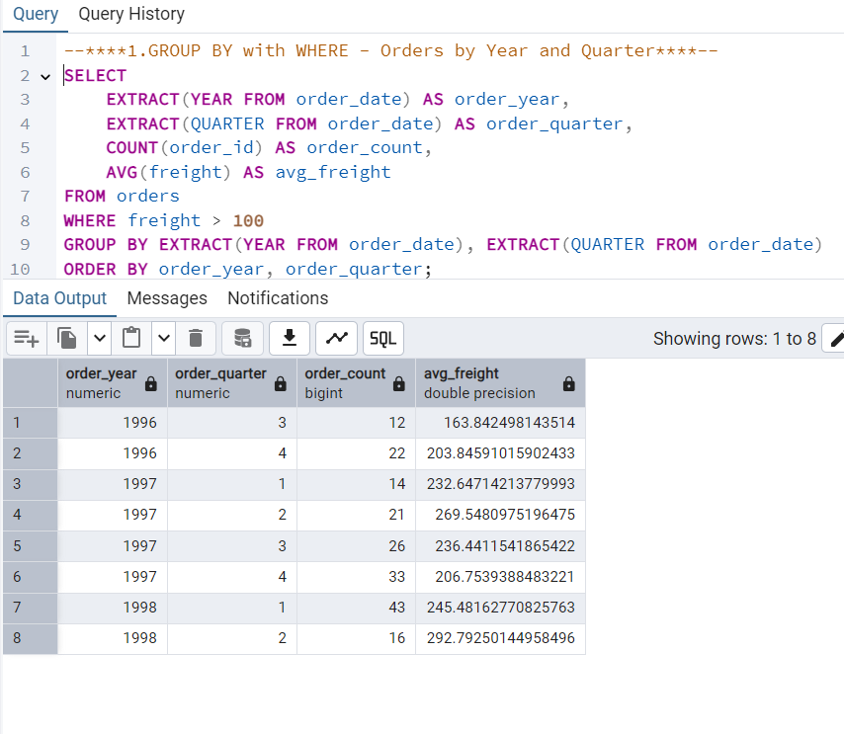
2. **GROUP BY with HAVING - High Volume Ship Regions**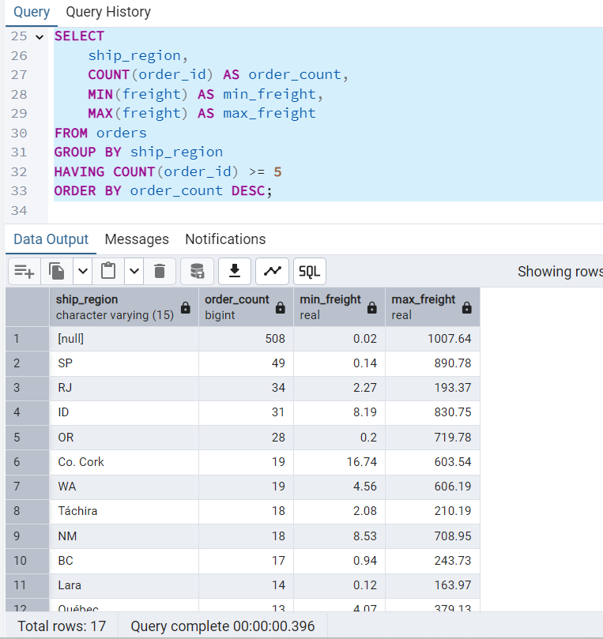  
   Display ship region, number of orders in each region, minimum and maximum freight cost.  
   Filter regions where number of orders >= 5.
3. **Get all title designations across employees and customers**  
   (Try using UNION and UNION ALL)  
   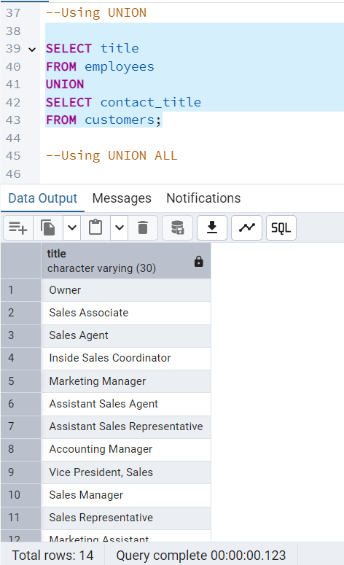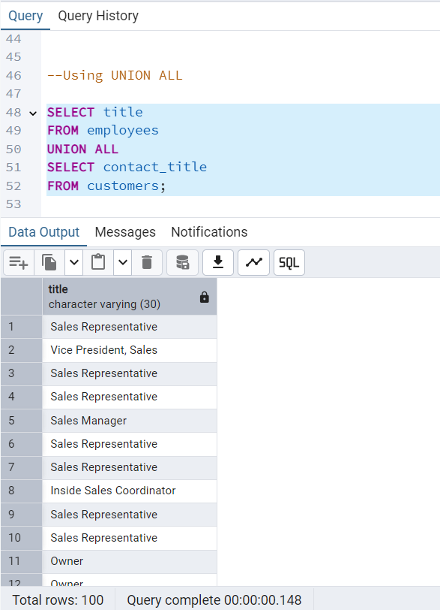
4. **Find categories that have both discontinued and in-stock products**  
   (Display category_id. "In-stock" means units_in_stock > 0. Use INTERSECT.)

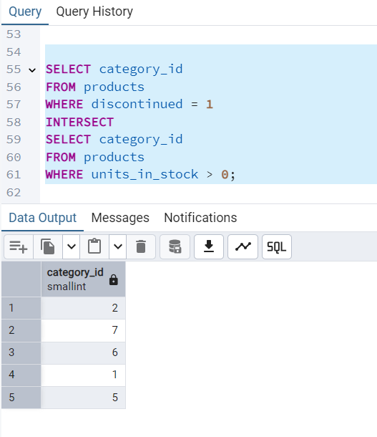

1. **Find orders that have no discounted items**  
   (Display order_id. Use EXCEPT.)

